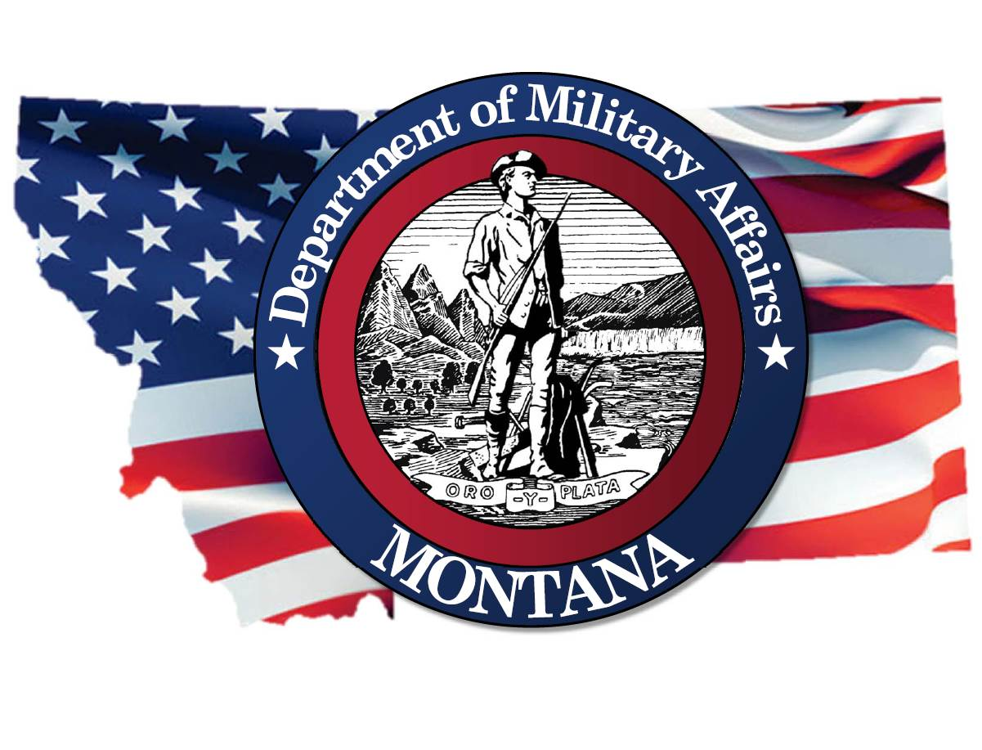
A READY AND RESILIENT MONTANA

DEPARTMENT OF MILITARY AFFAIRS

ANNUAL PLAN
FY2024

Executive Summary
Department’s Mission is to strengthen Montana through our collective readiness to defend against threats, increasing resilience, and engaged citizenship.
What do our divisions do?
Director’s Office Division. The Director’s Office Division performs the general fiscal administrative support functions for the department. Its activities include purchasing, information technology, accounting, budgeting, human resources, payroll, personnel, statistics, reports, and records management. Four large programs fall under the Director’s Office. These are the Montana Army Guard Program, Montana Air Guard Program, Montana Youth ChalleNGe Program, and the STARBASE Montana Program.
(b) Disaster and Emergency Services Division. The Disaster and Emergency Services Division duties and responsibilities are provided under Title 10, Chapter 3, MCA. The division is responsible for the coordination, development and implementation of emergency management planning, mitigation, response and recovery statewide. This responsibility includes the administration and disbursement of federal Homeland Security and Emergency Management funds to eligible political subdivisions and tribal nations across Montana. The division maintains a 24 hour a day point of contact to coordinate the volunteer, state, and federal response for assistance to political subdivisions and tribal nations in the event of an incident, emergency, or disaster.
(c) Veterans Affairs Division. The Veterans Affairs Division assist discharged veterans and their families, cooperates with state and federal agencies, promotes the general welfare and provides information on the veterans’ benefits. The division also administers the Montana state-run veteran’s cemeteries. The division reports to the Board of Veterans Affairs and operates under a state mandate provided in Title 10, Chapter 2, MCA.

What are we striving to improve this year?
Objective #1: An Empowered and Developed Workforce
Objective #2: Service to the Next Level
Objective #3: Mission-Focused: Establish clarity and purpose for agency programs

Strategic Outcome  #1 | Objective #1: An Empowered and Developed Workforce
A trained and empowered workforce ready for tomorrow’s challenges.
Strategies:
1. Develop transparent career management plans.
2. Provide pertinent and timely training to the next level.
3. Develop career ladders.
4. Provide competitive pay and benefits.
5. Empower leaders at the lowest level of execution.
6. Develop individual employee training plans.
 | Key  Measures | - 100% performance plan in state TALENT system and 100% quarterly check ins complete
 |  | - measuring longer tenure/turnover period, internal promotions, engagement and internal learning
 |  | - Increase leadership courses for supervisors

Strategic Outcome  #2 | Objective #2: Service to the Next Level
DMA provides the ability to grow in service through teamwork and duty.
1. Promote team-building.
2. Develop and implement systems to provide feedback on duty accomplishments.
3. Describe service opportunities in all job descriptions.
4. Promote and develop service opportunities for all generations.
5. Foster external relationships to expand service opportunities.
 | Key  Measures | - 14 events- increased Cadet and Mentor Applications
 |  | - Numbers of community/school partnerships created in comparison with prior years
 |  | - Completion of a recovery strategy.

Strategic Outcome  #3 | Objective #3: Mission-Focused: Establish clarity and purpose for agency programs
Mission-Focused: Establish clarity and purpose for agency programs in alignment with the DMA Mission.
- Develop operational plans that are reviewed and updated at least quarterly.
 | Key  Measures | - Create Operational Plans
 |  | - Check Plans are reviewed quarterly

